**TASKS**

1. Write a program to find the area of a triangle using function.

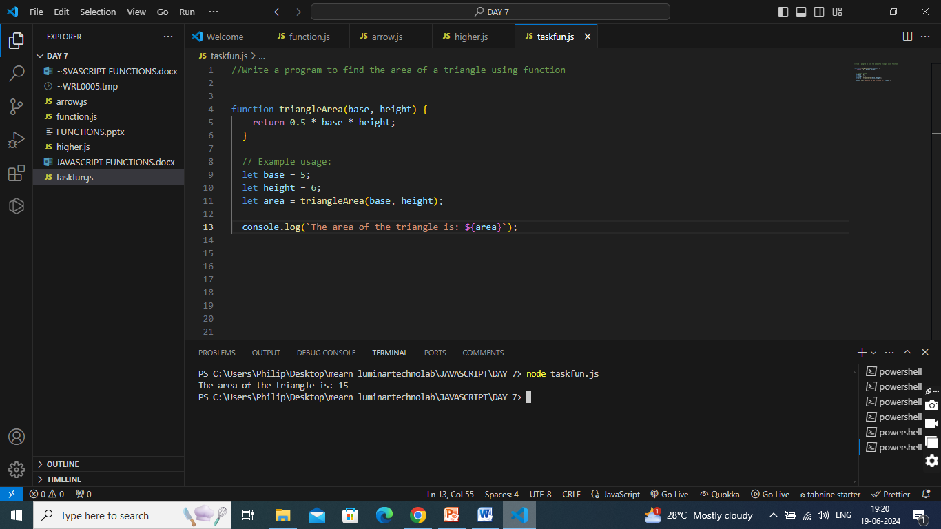

1. Write a JavaScript function that accepts a number as a parameter and check the number is prime or not.

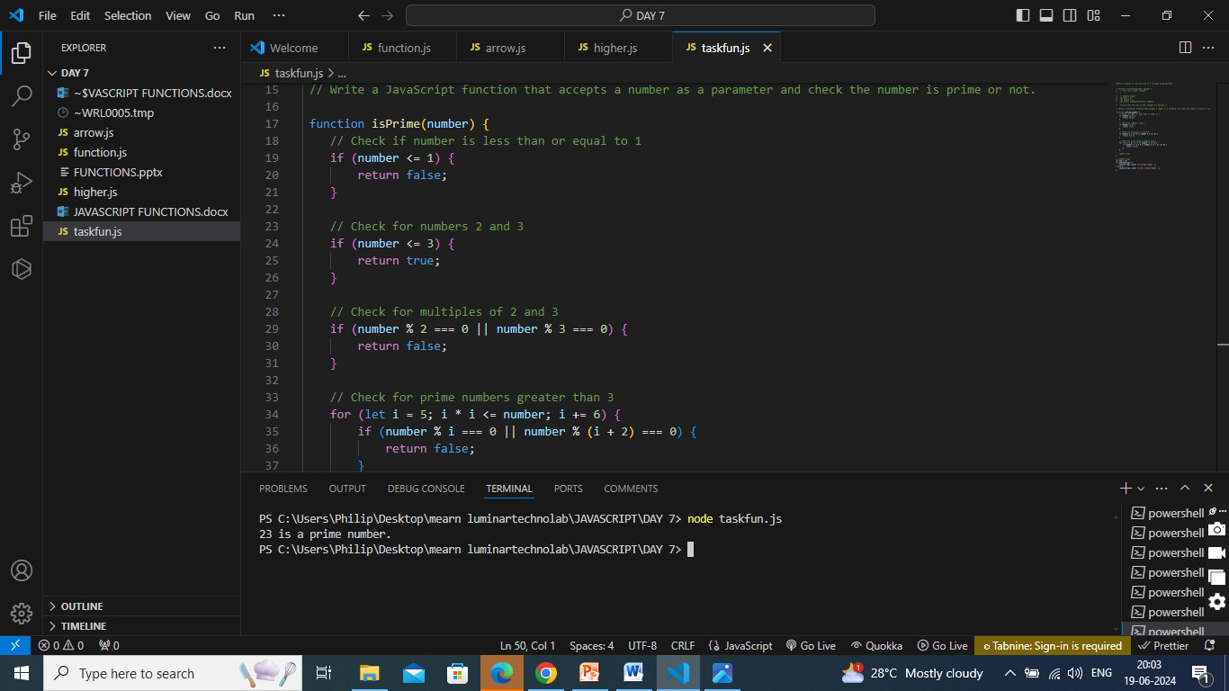

1. Write a JavaScript function that checks whether a passed string is palindrome or not?

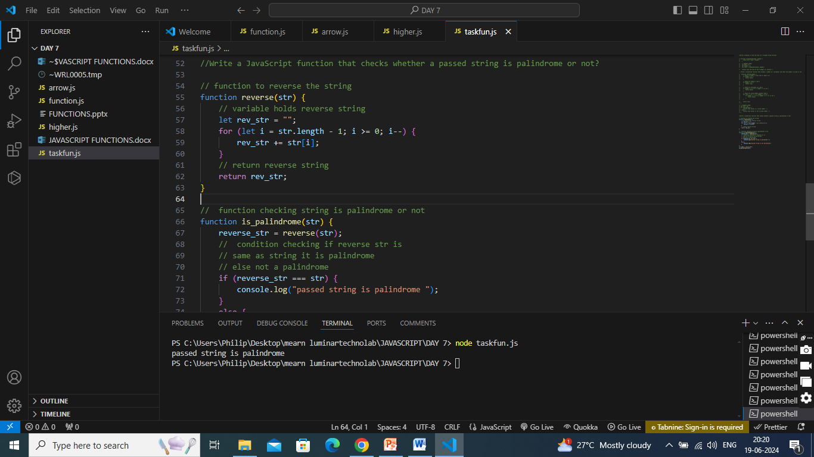

1. Write an anonymous function that takes two numbers as arguments and returns their product.

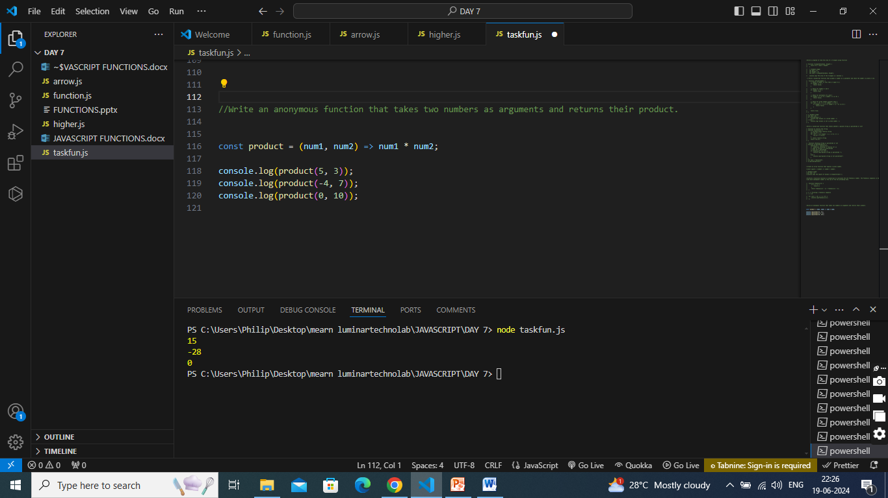

1. Create an arrow function that squares a given number.

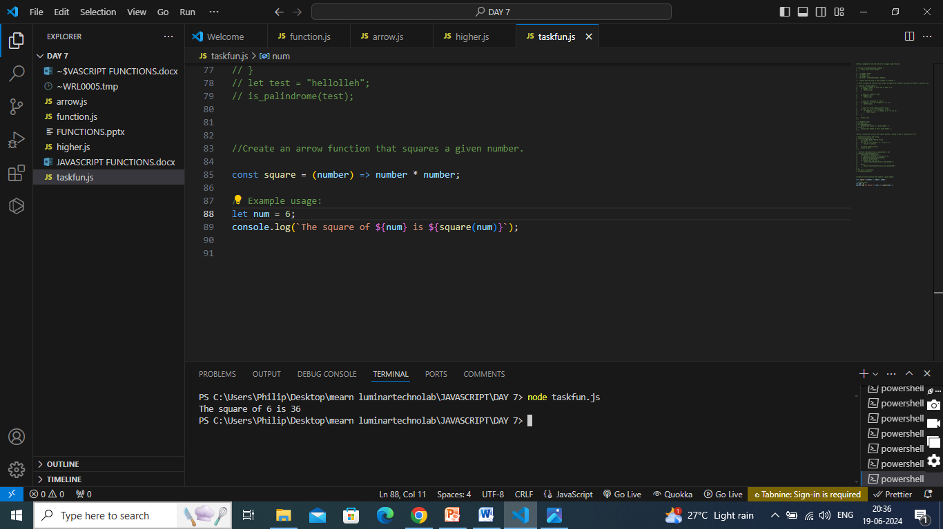

1. Write a recursive function in JavaScript to calculate the nth Fibonacci number. The Fibonacci sequence is defined as follows: the first two numbers are 0 and 1, and each subsequent number is the sum of the two preceding ones.

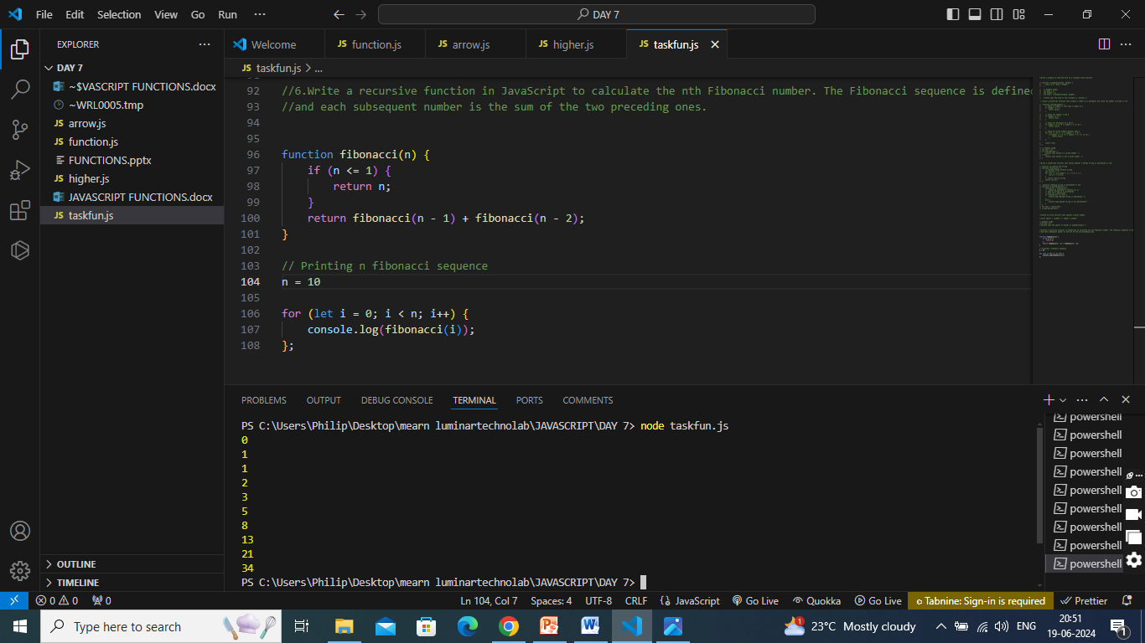

1. What is the difference between function parameters and arguments?

**Function Parameters:**

* Variables listed within the parentheses of a function definition.
* To act as placeholders for the values that will be passed to the function.

**Function Arguments:**

* Values passed to a function when it is called.
* To provide values to the function parameters.

1. What is the purpose of the return statement in a function, and what does it do?

In JavaScript, the "return" statement is used to specify the value that a function should output or "return" back to the caller. When a return statement is encountered within a function, the function will immediately stop executing, and the specified value will be sent back to the code that called the function.

1. What are the differences between arrow functions and regular functions in JavaScript?

**Arrow Function:**

* Shorter and more concise syntax
* Does not have its own this binding
* Does not have its own arguments binding
* Cannot be used as constructors
* Inherits the lexical scope of the surrounding code

**Regular Function:**

* Longer and more verbose syntax
* Has its own this binding
* Has its own arguments binding
* Can be used as constructors
* Has its own lexical scope

1. What is the difference between local and global scope in JavaScript functions?

**Global Scope:**

Global scope refers to the variables, functions, and objects that are declared outside of any function and are accessible from anywhere in the program. Global variables are created when the program starts and are destroyed when the program ends.

**Local Scope:**

Local scope refers to the variables, functions, and objects that are declared inside of a function and are only accessible from within that function. Local variables are created when the function is called and are destroyed when the function returns.

1. Create a Function to Convert Celsius to Fahrenheit using arrow function.

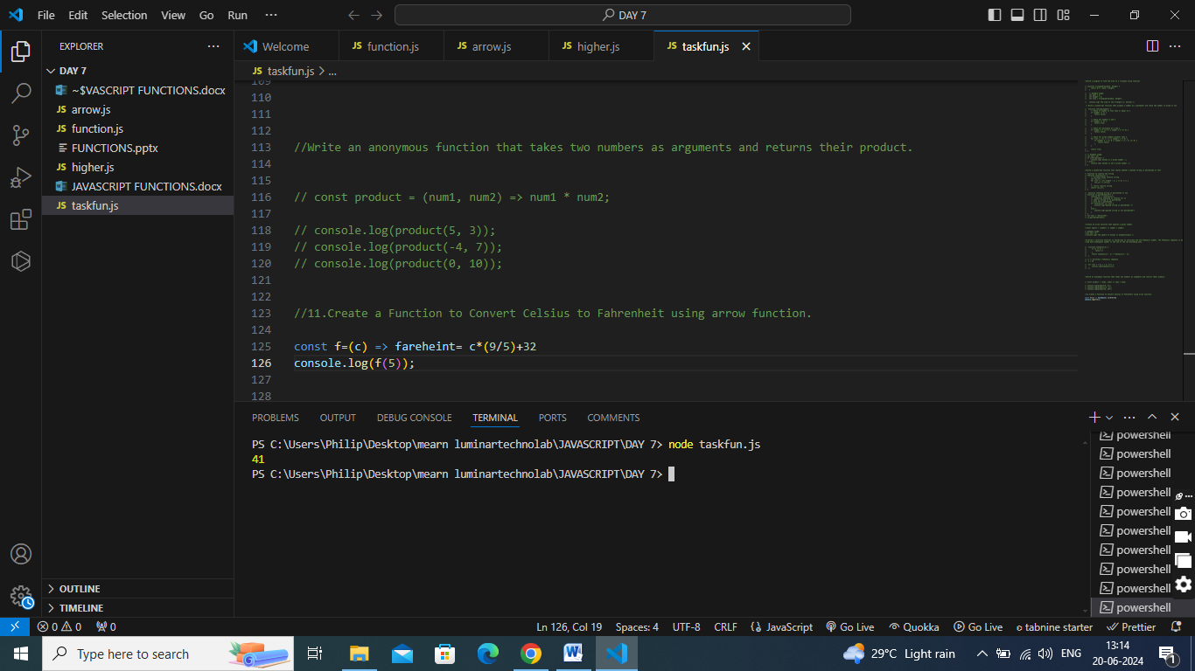

1. Create a Function to print Greeting Message using arrow function.

